Reviewer Comment #2
In Supplement 1 (K210528/S001), you have provided cell viability performance testing for the “IntelliFat” system. However, the complete test reports, including specified pass/fail criteria, complete data tables and test results (including any outlying and anomalous results), data analyses, etc. have not been provided. Furthermore, an explanation of how the data generated from the tests performed supports a finding of substantial equivalence has not been provided. As discussed in Item 15 of the checklist (page 5/13), FDA noted that the subject device contains the “Diamond-cut resizer” used to “create stromal vascular tissue (SVT)”, however, FDA further notes that the "creation of stromal vascular tissue" is not indicated by the identified predicate, Lipogems System (K161636). It is unclear how the data generated from the cell viability testing supports substantial equivalence to the predicate. Please provide the complete testing reports for all the tests performed to evaluate the subject device and explain how the data generated from the tests supports a finding of substantial equivalence to the predicate.

In response to the reviewer’s request, we have completed a comprehensive evaluation of the present device vs the predicate device, the results of which are found in Attachment 1, “IntelliFat and IntelliFat SVT versus Lipogems for the Harvesting and Processing of Adipose Tissue Lipoaspirate for Autologous Fat Grafting”. Both systems were evaluated for (1) general appearance of adipose tissue product at various stages throughout the processing steps, (2) presence/absence of oily liberated triglyceride signifying adipocyte damage prior to processing, (3) presence/absence of oil after processing, and (4) cell viability. In short, the present device and predicate device were found to be substantially equivalent in all these elements.
In the report below, we demonstrate that the present device and the predicate device share many identical or similar features, including, but not limited to:
- Mechanism by which adipose tissue is harvested (tumescent technique using VacLok syringe)
- Washing with saline to remove tumescent solutions and excess peripheral blood
- Application of filters to lipoaspirate to remove excess fluids prior to processing
- Mechanical fragmentation of suctioned adipose tissue
- Sterile syringes, transfer connectors, syringe caps and other accessories to aid in processing of lipoaspirate to produce minimally manipulated micro-fragmented adipose tissue.
Meanwhile, primary differences exist in the following areas:
- Design of the harvesting cannulas
- Primary mechanism by which adipose is mechanically fragmented

The most significant difference relates to the user applying the DiamonCut resizer to deagglomerate adipose tissue whereas manual shaking of the processing unit of the predicate device is used in order to achieve adipose tissue reduction.


The study was conducted by Wangzhong Sheng, Ph.D., Chief Scientific Officer of Cellmyx. Dr. Sheng obtained his Ph.D. from the University of California, San Diego, where he completed his dissertation on applying nanotechnology in the context of liposuction, making him one of a handful of experts on adipose tissue and liposuction. During his Ph.D., he developed many in vitro and in vivo assays to evaluate this novel technology, many of which are employed in the present study, such as the test to evaluate for the presence/absence of oily triglycerides within the adipose tissue lipoaspirate as an indicator of lipolysis, or damage to adipocytes (fat cells.)

Appendix I: IntelliFat and IntelliFat SVT versus Lipogems for the Harvesting and Processing of Adipose Tissue Lipoaspirate for Autologous Fat Grafting

Objective
The objective of this study was to compare the intelliFat (and intelliFat SVT) disposable adipose tissue harvesting, processing, and transfer kit against the predicate device, also called Lipogems, in a head-to-head comaprison study. The study was performed in triplicate (n=3).

Primary outcomes
The primary outcomes of this study were:
- Appearance of adipose tissue products
  - Prior to processing, as adipose tissue clusters,
  - After processing using each device
    - The metric was derived from the predicate device description, which states:
“The performance of the device is entirely controlled by the user and is not predetermined by the device itself. The instructions for use advise the user to process the tissue by waving and shaking the unit vigorously for a few minutes to emulsify the content. The instructions continue by identifying that when the processing phase is complete, fat tissue will appear compact, light yellow in color, floating on the transparent liquid phase.”
    - We used this description to define the outcome of this evaluation.
- Absence/presence of oil, which signals damage to adipocytes, prior to processing with each device.
- Absence/presence of oil, which signals damage to adipocytes, after to processing with each device.
- Cell viability by propidium iodide assay, via Moxi Flow™ Automated Next-Gen Flow Cytometer
  - *Viability is performed on “Stromal vascular fraction” (SVF) of the adipose tissue lipoaspirate. Although neither the present device nor the predicate device is meant to be used to isolate the SVF, as SVF is not 361-compliant, for the purposes of demonstrating significant equivalence, the viability of the SVF was assessed, per discussion with the reviewers.
  - Furthermore, we’d like to point out to the reviewer that, despite the name ‘Stromal Vascular Tissue” of the IntelliFat SVT product, the reviewer will see below that at no time does the IntelliFat/IntelliFat SVT product separate out the SVF portion of the adipose tissue, nor is there any other separation, re-mixing, or addition of any other HCT/P’s into the harvested adipose prior to, or after re-introduction of the adipose tissue product back into a patient.
  - An alternative assay involving collagenase digestion of adipose tissue followed by assaying for viability of remaining adipocytes was also considered and discussed with the reviewers but was ultimately not selected due to its known risk of damaging cells and altering the outcome of the viability measurement via the chemical digestion process.
  - Objective pass rate is ≥85% viability.

Materials
- IntelliFat or IntelliFat SVT disposable adipose tissue harvesting, processing, and transfer kit (present device)
  - The full list of items included in both kits are documented under the detailed device description section of this submission, as well as with the response to reviewer document.
- Lipogems adipose tissue kit (predicate device)
  - The full list of items included in both kits are documented under the detailed device description section of this submission, as well as with the response to reviewer document.
- Adipose tissue lipoaspirate was obtained from a single patient with standard tumescent liposuction technique by one of Cellmyx’s collaborating physicians.
  - Four tubes, up to 60 mL each, was collected using the harvesting canula from each device (intelliFat superG Milli cannula or Lipogems harvesting cannula), for a total of eight tubes of lipoaspirate.
  - For reference, the predicate device employs a single, sterile packaged, stainless steel, multi-holed, blunt tip Harvesting Cannula, with five (5), oval-shaped apertures having 5 mm longitudinal diameter, arranged concentrically about the shaft of the cannula body, at 120° intervals, within 1 ½ in of the cannula tip (left, below). Meanwhile, the present device employs a blunt-tipped Harvesting Cannula with a 2.5 mm inner diameter (approximately 12ga.), 15 cm long, with 21, 1.2mm-sized apertures arranged concentrically about the cannula cylinder with seven apertures each arranged in a staggered manner on three of the four “sides” of the cannula body (below, right). In comparison to the predicate device’s harvesting cannula, the apertures of this cannula are approximately ¼ the size, but there are approximately four times as many apertures, so the overall “suction surface area” is approximately the same between the two cannulas.
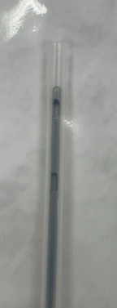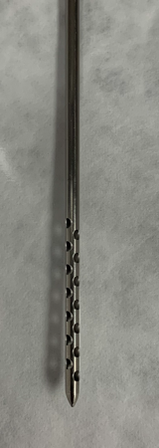
*Pictures are only approximately to scale.
  - No informed consent was collected, nor needed, per 21 CFR 812.2(c)(3) of FDA guidelines since the adipose tissue lipoaspirate would have been otherwise discarded, and no patient identifiers or tags were associated with the samples collected.
  - The collaborating physician is a board-certified plastic surgeon who is trained in, and routinely performs, liposuction.
- Disposable materials needed for the operation of both kits include but are not limited to:
  - Lactated ringers to rinse adipose tissue lipoaspirate
  - Phosphate buffered saline, Ca²⁺, Mg²⁺-free, for suspension and dilution of cell pellets
  - Pipettes and disposable pipette tips (1mL and 200µL)
  - Single-use, sterile disposable syringes, 10mL, 60mL
  - Centrifugal tubes, 10mL, 50mL
- Orflo MoxiFlow Automated Next-Gen Flow Cytometer http://www.orflo.com/product_p/mxf002.htm
- Orflo MoxiFlow Disposable Cassettes
http://www.orflo.com/product_p/mxc021.htm
- Orflo MXA055 MoxiCyte Viability Reagent (pre-formulated propidium iodide solution)
https://www.orflo.com/ProductDetails.asp?ProductCode=MXA055
- Centrifuge

Method and Results

Pre-processing of Adipose Tissue Lipoaspirate
Adipose tissue lipoaspirate was collected into 60 mL syringes using the harvesting cannulas provided with each kit. The harvested lipoaspirate naturally gravity separated during transport into an adipose tissue-rich layer, above, and a tumescent fluid layer, below, which were divided into separate 50mL centrifugal tubes for each sample (see example images below). The pinkish tumescent fluid fraction was discarded while the yellow adipose tissue fraction was used for all studies. For reference, this is how the lipoaspirate would be treated during an actual procedure for both devices – gravity decanting/separation of harvested lipoaspirate followed by discarding of separated aqueous tumescent liquid layer and processing of remaining adipose tissue fraction.
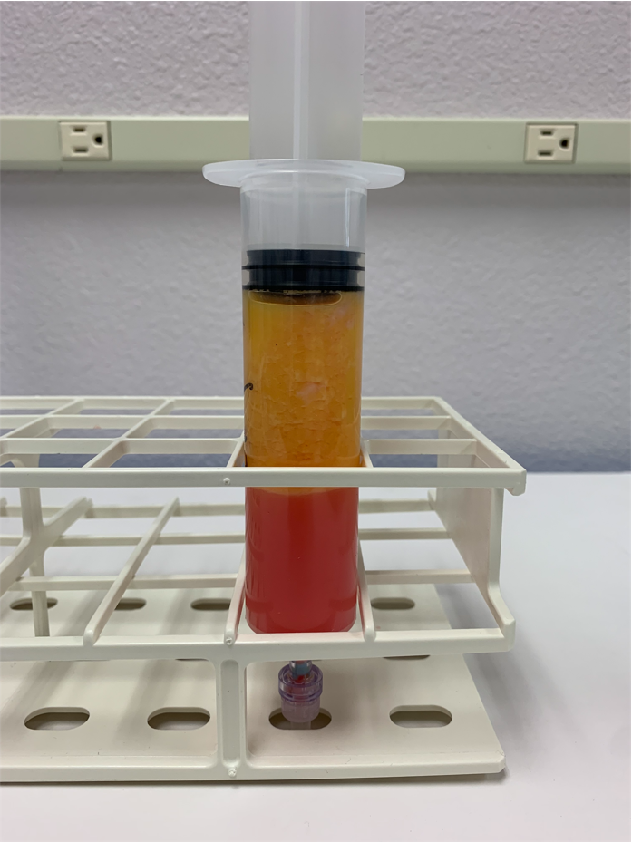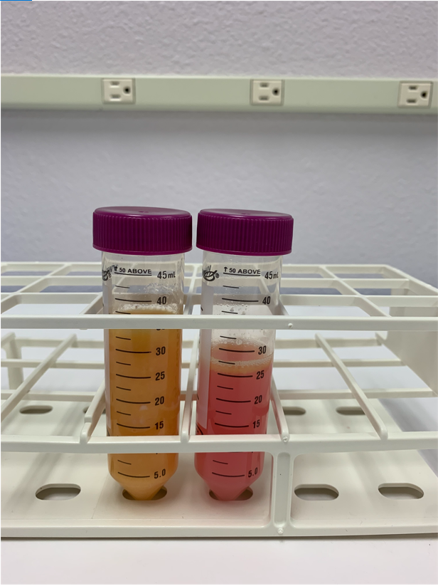

Assessment for absence/presence of liberated triglycerides (oil) from harvesting process
After the tumescent fluid had been removed, two lower-volume samples from each group were centrifuged at 300 x g for 5 min, the standard centrifuging speed for processing adipose tissue without impacting tissue properties (because higher speeds will lead to bursting of adipocytes and the appearance of triglycerides), to visualize the impact of the adipose tissue harvesting process on the adipose tissue.
We would like to note here that centrifugation is NOT performed under clinical settings for neither the predicate (Lipogems) nor the present (intelliFat) device, and that this test was merely performed in order to visualize the oil fraction produced as a result of the adipose tissue harvesting process to establish a baseline for the amount of oil expected in the tissue.
Due to the variability in the fraction of the lipoaspirate that is adipose tissue, which is common since the ratio of adipose tissue to tumescent solution changes as a plastic surgeon collects more and more lipoaspirate, we tried to compared samples with the similar volumes of adipose tissue. For the first set of samples, which had approximately equal volumes of adipose tissue to allow for the most direct comparison, a thin layer of oil was observed for both the intelliFat and Lipogems samples, with slightly more oil in the IntelliFat sample (labelled ‘SVT’). Pictures were taken with the flash on in order to better distinguish between the relatively more transparent oily layer and the opaque intact adipose tissue layer. A thin layer of oil is not uncommon for adipose tissue lipoaspirate, as the mechanical harvesting process may lead to minor damage to the harvested adipocyte, and the amount of oil observed for both samples are well within this expected normal range.
Comparison of a second set of samples showed a similar thin layer of oil in the IntelliFat sample (again, labeled ‘SVT’), but much more oil was observed in this Lipogems sample compared to the first Lipogems sample, as well as either of the two IntelliFat samples, despite having a smaller total volume of adipose tissue. Therefore, based on these results, we demonstrate that harvesting of adipose tissue using the SuperG Milli cannula from the IntelliFat/intelliFat SVT devices was no worse than harvesting of adipose tissue using the Harvesting cannula from the predicate device. Additionally, because these sample were centrifuged, which is not considered standard treatment, they were NOT used for subsequent analyses.
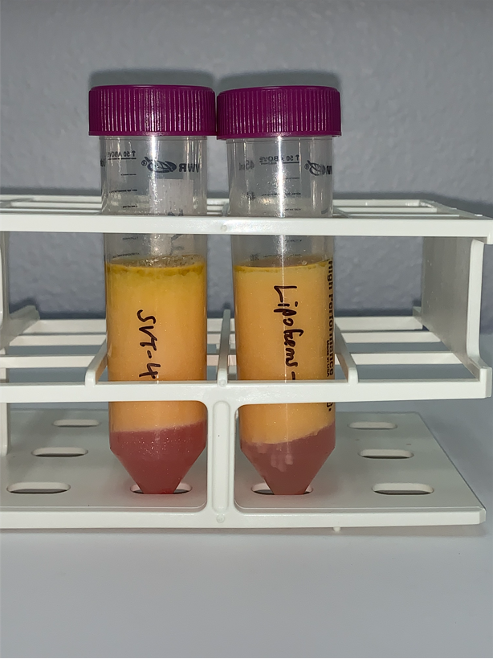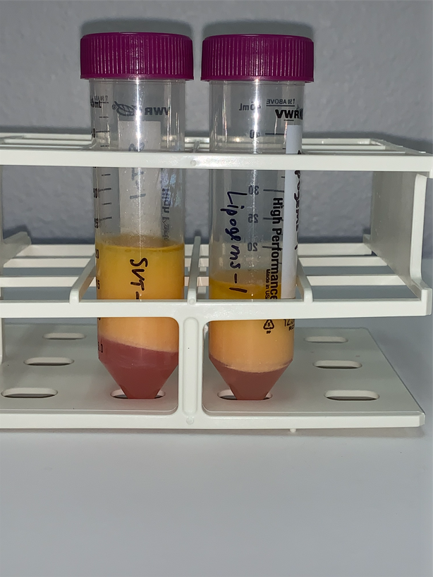
- Based on this outcome, we demonstrate that the adipose tissue lipoaspirate collected by the harvesting canula of the present device is substantially equivalent to the adipose tissue clusters collected by the predicate device due to the comparable amount of liberated triglycerides/oil found in the adipose tissue fraction of the lipoaspirate.

Evaluation of Adipose tissue cluster size
A total of four tubes of lipoaspirate was collected for each device. From an uncentrifuged tube of lipoaspirate, a 1 mL pipette tip was used to ‘dab’ and deposit adipose tissue onto a paper towel to enable visualization of the adipose tissue cluster sizes from the lipoaspirate collected using the different cannulas from each device.
The adipose tissue clusters collected using the harvesting cannula from the predicate devices resulted in larger, and a more heterogenous distribution of cluster sizes (right, ‘Lipogems’, in image below), while the harvesting cannula from the present device resulted in smaller, and a more homogenous distribution of cluster sizes (left, “IntelliFat”, in image below). This result is consistent with the difference in aperture sizes between the two cannulas from the two devices.
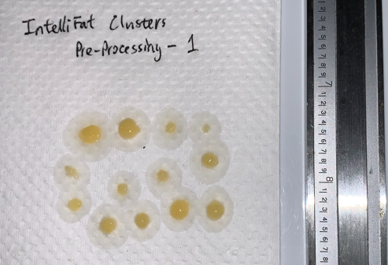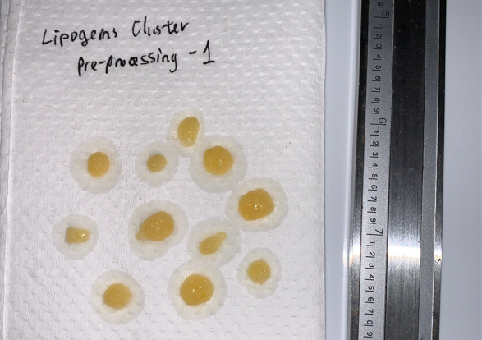
*Units on ruler = 1 in.
Clusters from all three attempts are depicted in the images below.
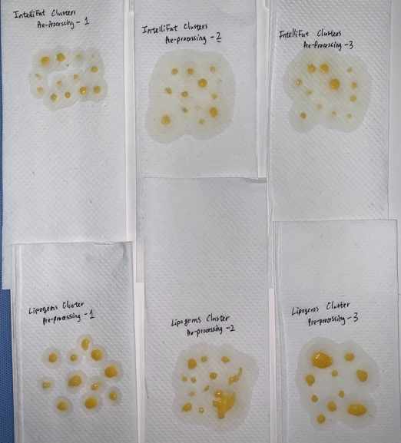
The adipose tissue clusters were also allowed to air dry in order to visualize the properties of the adipose tissue. For reference, adipose tissue is organized in a hierarchical manner, as described by Dr. Jeffrey Klein in his authoritative textbook on liposuction: https://liposuction101.com/liposuction-textbook/chapter-25-subcutaneous-fat-anatomy-and-histology/. At the base level are adipocytes (100-150 µm; not individually distinguishable to the naked eye), which are organized into lobules (10-50 cells), which are in turn, organized into pearls (mm in size). On a more macroscopic scale, pearls are organized into sections and then compartments. When adipose tissue clusters are harvested, it is performed on the “pearl” level, evidenced by the approximately millimeter sized “clusters” collected by the harvesting cannulas of each device. Below, we show a “dried” version of adipose tissue to demonstrate that, despite having smaller clusters, adipose tissue collected using the harvesting cannula from the present device maintains the properties of adipose tissue, as lobules can be clearly distinguished within the individual clusters of adipose tissue (Image below: dried adipose tissue clusters for adipose tissue collected using the harvesting cannula from the predicate device, left, vs adipose tissue clusters collected using the harvesting cannula from the present device, right).
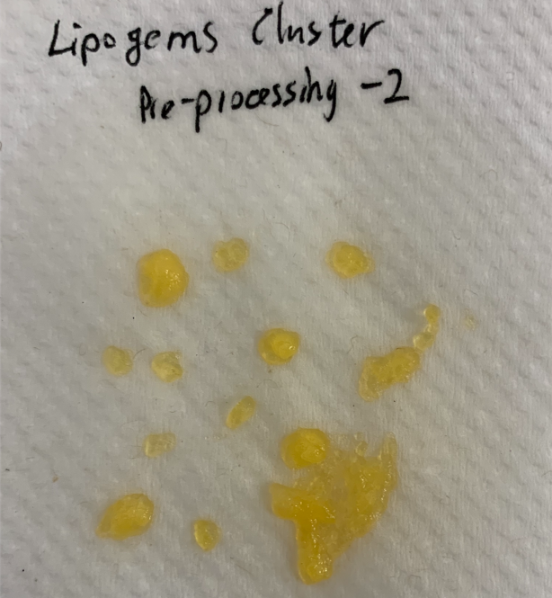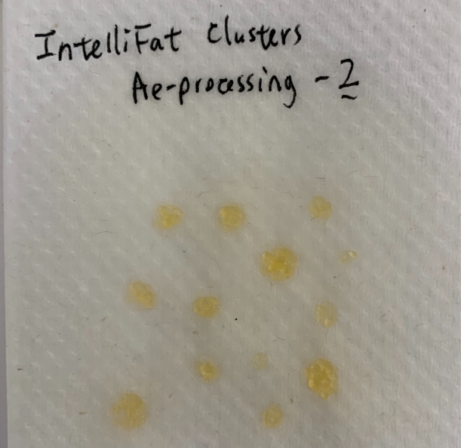
- Based on this outcome, we demonstrate that the adipose tissue clusters collected by the harvesting canula of the present device is substantially equivalent to the adipose tissue clusters collected by the predicate device, if not slightly better, due to its improved uniformity and consistency in the adipose tissue cluster sizes.

Resizing of adipose tissue clusters

Processing of Adipose Tissue Lipoaspirate using the IntelliFat/IntelliFat SVT System
Adipose tissue processing was performed under the instructions for use provided with the IntelliFat and IntelliFat SVT kit. Parameters such as wash volumes were adjusted accordingly to match those used in the processing of the adipose tissue lipoaspirate by the predicate device. Briefly:
- 10 mL of adipose tissue was mixed with 50 mL of Lactated Ringers solution in a 60 mL syringe and mixed by inverting the syringe. The contents of the syringe were allowed to gravity separate back into an adipose tissue layer, above, and an aqueous wash layer, below (see images below). The aqueous was layer was discarded and the residual adipose tissue was washed once again with another 50 mL of lactated ringers. The wash fluid of this second wash was clearer than the wash fluid of the first (not shown).
- After allowing the contents of the syringe to gravity separate again, the wash solution was discarded and the remaining contents of the syringe were transferred to a 10 mL syringe. To this syringe, the DiamondCut Resizer component of the IntelliFat kit, which is described in more detail in the other section of this “Response to Reviewers” document, was attached to the syringe via the Luer connector, and an empty 10 mL syringe was attached to the opposite end (see below).
- The adipose tissue was passed back-and-forth 10 times (total of 20 passes one-way through the resizer; the resizer does not have directionality, so passing the tissue through one way is identical to passing it through the other way), to mechanically resize the adipose tissue to produced micro fragmented fat (microfat).
- The collected, processed adipose tissue is the adipose tissue product that would be used for autologous fat transfer in a clinical setting.
- It should be apparent to the reviewer that despite the name ‘Stromal Vascular Tissue” of the IntelliFat SVT product, at no time during processing does the IntelliFat kit separate out the SVF portion of the adipose tissue, nor is there any other separation, re-mixing, or addition of any other HCT/P’s into the harvest adipose prior to, or after re-introduction of the adipose tissue product back into a patient.

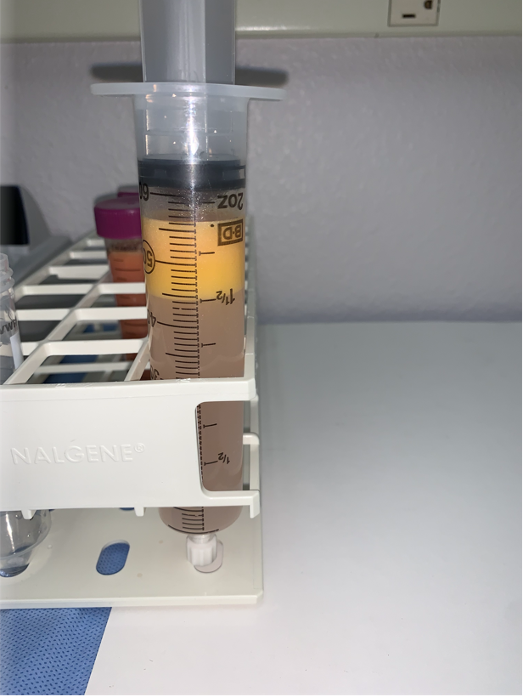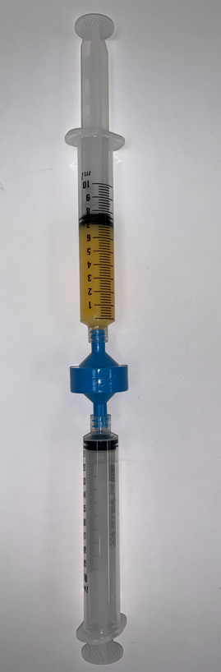

Processing of Adipose Tissue Lipoaspirate using the predicate Lipogems System
Adipose tissue processing was performed under the instructions for use provided with the predicate device (Lipogems). The model/size of the predicate device used was the LGD-60, which comes with a 60 mL cylinder, and can accommodate up to 15 mL of adipose tissue for processing at a time. For consistency with the intelliFat/intelliFat SVT procedure, we elected to process 10 mL of adipose tissue, with two 50 mL washes. Below is an image of the adipose tissue loaded into the jar/cannister system of the predicate device, prior to “shaking” of the device to mechanically resize the adipose tissue to produced micro fragmented fat (microfat).
Compared to the procedure for the present device, the procedure for the predicate device is longer and more complex. For brevity, we elected not to re-write them here. A video of the device’s operation can be found here: https://pacmedical.com/lipogems-adipose-tissue-treatment/ In short, the jar was shaken for two 30-second segments, with replacement of the washing fluid between each shaking segment.
Like the adipose tissue product produced at the end of the intelliFat/intelliFat SVT processing, the collected, processed adipose tissue is the adipose tissue product that would be used for autologous fat transfer in a clinical setting.
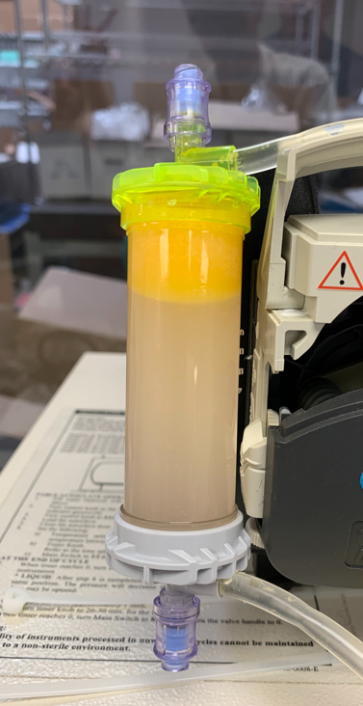

Processed Adipose Tissue Products from intelliFat/intelliFat SVT versus Predicate Device (Lipogems)
In general, the adipose tissue product produced from Lipogems had a “yellower’ appearance (left tube, in both images, below), while the adipose tissue product produced from intelliFat and intelliFat SVT had a “whiter”, more “frothy” appearance (right tube, in both images, below). It was also apparent that the adipose tissue product produced from intelliFat was “dryer”, or contained proportionally more adipose tissue, after brief gravity separation.
Nevertheless, despite these minor visual differences, the processed adipose tissue product from the predicate device was largely indistinguishable from the the adipose tissue product from the present device.

- Based on this outcome, we demonstrate that the adipose tissue product produced by the present device is substantially equivalent to the predicate device, due to the nearly identical appearance of the adipose tissue product produced by both devices.

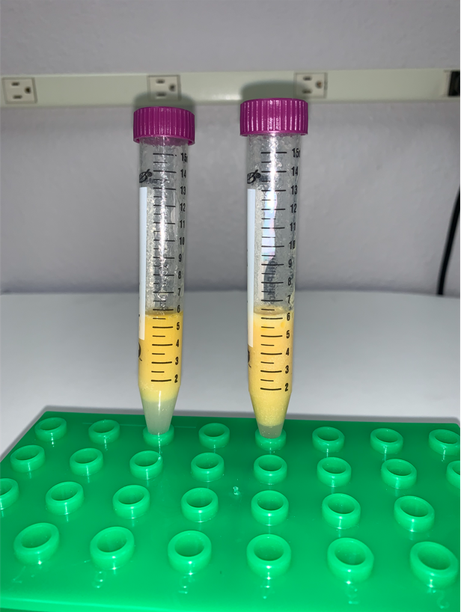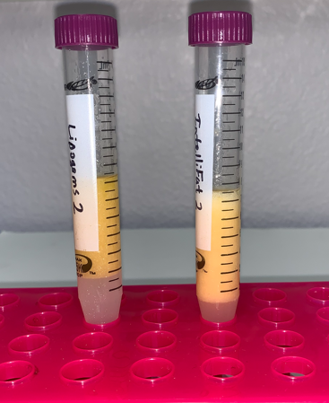
Images of processed adipose tissue product using the predicate device (Lipogems), left, in both images, and the present device, Intellifat/IntelliFat SVT, right, in both images. This is what would be injected back into the patient for autologous fat transfer procedures. Pictures were taken with the “flash” on in order to visualize the presence of any oily triglycerides that may have been produced; No oil is observed in this state in the adipose tissue product produced from either device. (Note: A third set of comparison was performed, but images were not taken and therefore, could not be shown here.)

Assessment for absence/presence of liberated triglycerides (oil) in adipose tissue products post-processing
To assess the amount of oil produced after processing with each device, samples were centrifuged at 300 x g for 5 min to determine the presence/absence of a liberated triglyceride oil layer. We would like to note once again here that this treatment is not applied in a clinical setting, but rather used experimentally to identify any triglycerides that may have been liberated from the adipocytes as a result of processing.
In the first set of samples, significant oil had formed in the predicate device (left tube, in left image) compared to the present device (right tube, in left image), although a very slight section of oil near the middle of the adipose tissue fraction could also be observed in the adipose tissue of the present device. In the second set of samples, much less oil, although a small amount, could still be observed in the adipose tissue product processed using the predicate device (left tube, in right image), while no oil at all was observed in the adipose tissue product processed by the present device (right tube, in right image). Again, all pictures were taken with the “flash” on in order to distinguish the more transparent oily layer from the more opaque, intact adipose tissue layer. Interestingly, a thin white layer, likely remnant of the “froth” observed in the adipose tissue product processed by the present device, can be observed clearly in the intelliFat samples. This “froth” likely forms due to trapped air bubbles that are passed back-and-forth repeatedly while resizing through the DiamonCut resizer.
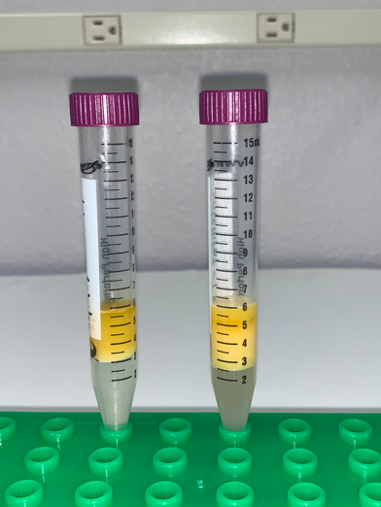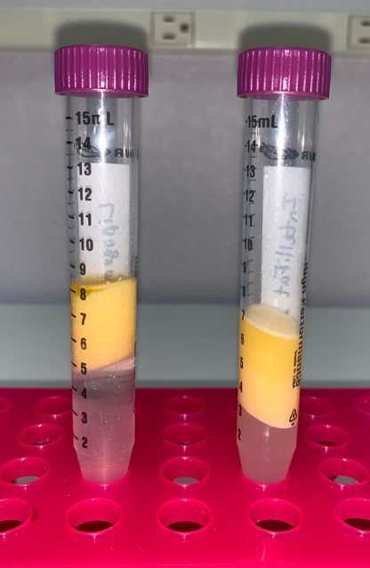
Images of processed adipose tissue product using the predicate device (Lipogems), left, in both images, and the present device, Intellifat/IntelliFat SVT, right, in both images, after centrifugation.
- Based on this outcome, we further demonstrate that the adipose tissue product produced by the present device is substantially equivalent, if not in fact, slightly better, than the predicate device, due to the reduced amount of liberated triglycerides/oil observed in the adipose tissue layer.

Assessment of Cell Viability of the SVT fraction of the Adipose Tissue Lipoaspirate
As we mentioned previously, which we would like to reemphasize here, neither the predicate device nor the present device is meant to be used to isolate the Stromal Vascular Fraction, or SVF, of the adipose tissue product. Furthermore, we’d like to remind the reviewer that despite the name ‘Stromal Vascular Tissue”, or “SVT” of the IntelliFat SVT product, it is clear that at no time did the intelliFat/intelliFat SVT product separate out the SVF portion of the adipose tissue, other than here, for this assessment, nor is there any other separation, re-mixing, or addition of any other HCT/P’s into the harvest adipose prior to, or after re-introduction of the adipose tissue product back into a patient. For the purposes of evaluating the viability of the cells in the adipose tissue product produced by both devices, we were advised by the reviewer to perform an evaluation of the SVF as the next best means of evaluating cell viability, using a standard assay such as Trypan blue or Propidium Iodide, with the understanding that this process and evaluation is not in line with the product’s actual intended use.
For the purposes of this evaluation, we elected to use the MoxiFlow Automated Next-Gen Flow Cytometer and its accessories, to evaluate the cell viability of the SVF produced from the adipose tissue products of both devices. This cell counter operates based on Coulter-counting principles, as is standard for many automated flow cytometers.
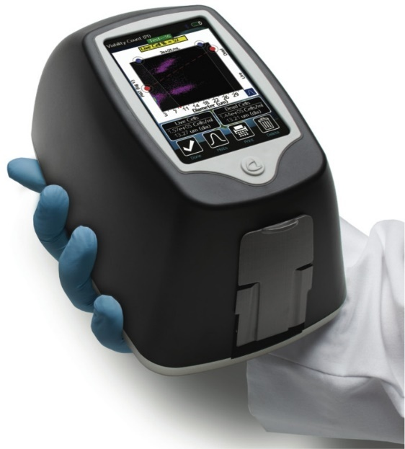
MoxiFlow Automated Next-Gen Flow Cytometer used to determine cell viability.
We elected to use the pre-made propidium iodide (MoxiCyte MXA055) reagent and the accompanying disposable cartridge for this device to perform the cell viability assay. Briefly, after centrifuging, the adipose tissue and residual aqueous layers were all discarded, leaving behind a small but visible cell pellet (see below). The pellet was suspended in 1 mL of calcium and magnesium free phosphate buffered saline (PBS). All sample, for processed adipose tissue from both the present and predicate device, were prepared in the same manner, e.g. same volume of dilution.
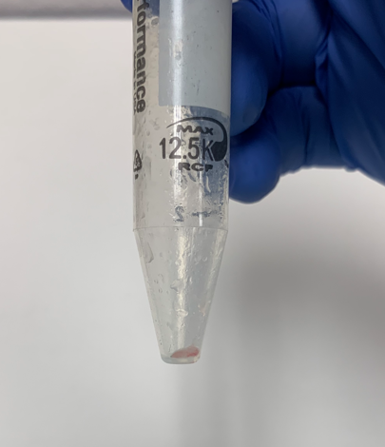
To prepare the suspension for assaying, 15 µL of the cell suspension was mixed with 135 µL of the reagent, or any multiple thereof, and allowed to incubate, protected from light, for 5 min. 75 µL of the sample was then added to the microfluidic channel of the disposable cartridge and assayed for cell diameter, count, and viability. Below is a sample image of the readout from the instrument:
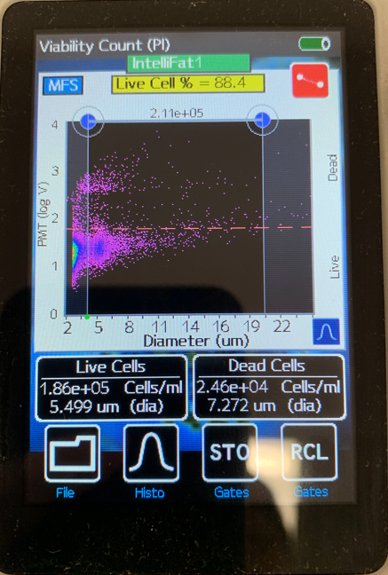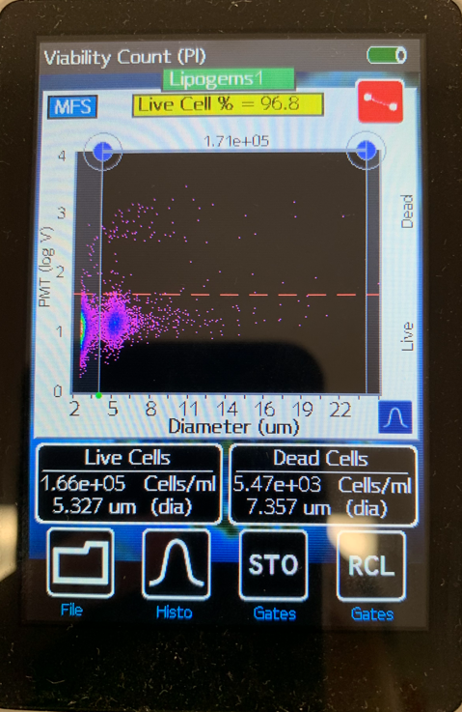
Cell viability result from MoxiFlow instrument showing cell count, diameter, and viability. Horizontal gates were set based on the PMT (log V) for each measurment, while vertical sizing gates were set to exclude small particles that may be oil droplets dissolved in solution, or other small, non-cell debris, which was present in all samples.

Below are the results of this evaluation for adipose tissue derived from the intelliFat/intelliFat SVT device, or, from the predicate (Lipogems) device.

 | IntelliFat
 | Viability | Pass/Fail | Cell Count | Avg Cell Diam. (µm)
Run 1 | 88.40% | Pass | 2.11E+05 | 5.50
Run 2 | 86.40% | Pass | 8.72E+04 | 5.29
Run 3 | 86.90% | Pass | 1.11E+05 | 5.42
Average | 87.23% |  | 136400 | 5.40
Std Dev | 1.04% |  | 65692 | 0.11
 | Lipogems
 | Viability | Pass/Fail | Cell Count | Avg Cell Diam. (µm)
Run 1 | 96.80% | Pass | 1.71E+05 | 5.33
Run 2 | 98.50% | Pass | 2.12E+05 | 5.18
Run 3 | 98.10% | Pass | 1.91E+05 | 5.22
Average | 97.80% |  | 191333 | 5.24
Std Dev | 0.89% |  | 20502 | 0.08

The average diameter of the cells of the SVF of the adipose tissue processed using intelliFat was 5.4 ± 0.11 µm while the average diameter of the cells of the SVF of the adipose tissue processed using Lipogems was 5.24 ± 0.08 µm, both of which are consistent and well within the expected size range of the target cell populations (fibroblasts, endothelial cells, mesenchymal stem cells). In the flow cytometer readout, two distinct populations could be observed, with one population at ~2 µm size range or less, and the other population around ~5 µm that appaears to be the cell fraction, since the smaller fraction is too small to be cells. We speculate that this smaller fraction may instead be residual oil microdroplets or debris that is not removed during processing. Additionally, the similarily in the flow cytometry profiles give us confidence that we are indeed assessing the appropriate fraction.
The cell count for the SVF of the adipose tissue processed using the present device was 134600 ± 65700 and the cell count for the SVF of the adipose tissue processd using the predicate device was 191333 ± 20502. The slight difference in cell count may be attributed to slight variations in handling and processing of the samples. We would like to also note that the cell count is not actually representative of the total population of cells, as a significant portion of the total number of cells remains entangled/entrapped within the intact adipose tissue fraction that was discarded.
Finally, in terms of viability, we set the pass criteria as a viability ≥ 85%. The SVF of the adipose tissue processed using the intelliFat/intelliFat SVT device was 87.23 ± 1.04% while the viability of the SVT of the adipose tissue processed using the Lipogems device was 97.8% ± 0.89%. While the cell viability found for the predicate device was approximate 10% higher than the cell viability found for the present device, all samples processed using either device passed the viability assessemnt by the objective criteria of ≥85%. The slightly reduced viability of the SVF may be attributed to the back pressure produced inside the syringe during the passing back-and-forth of the adipose tissue through the resizer, while the macroscopic process of the ball bearings in the predicate device may not be as detrimental to the cells. However, as we noted above, the macroscopic process is more harmful to the TISSUE, evidenced by the presence of more oil in the adipose tissue product from the predicate device, compared to the syringe-based, mechanical resizing achieved by the DiamondCut resizer of the intelliFat/intelliFat SVT device.
- Based on this outcome, we demonstrate that, the cell viability of the cells from the adipose tissue product produced by the present device passes based on objective measures (>85%) and is therefore substantially equivalent, albeit the viability was slightly reduced compared to the viability of the cells from the adipose tissue produced by the predicate device.

Conclusion
In this study, we evaluated the treatment of adipose tissue, from harvesting, processing, to post-processing, using the present IntelliFat/IntelliFat SVT device, and compared it to the predicate Lipogems device, and found the two devices to be substantially equivalent in every way, from harvested adipose tissue cluster size, to the presence of liberated triglycerides/oil both prior to, and after processing, as well as cell size, count, and viability.

Appendix – Supplemental images
